Barco Home Assignment

Test plan flow chart 2

Test Item list 3

Browser compatibility 3

Redirect URL 3

SN 3

Web Cache 3

API 3

Test Case list 4

Issue Note 7

Bug ID:0001 7

Bug ID:0002 9

Bug ID:0003 10

Bug ID:0004 11

# Test plan flow chart

# Test Item list

Browser compatibility

Chrome/ Firefox/ IE

Redirect URL

HTTP/ HTTPS

SN

Positive/ Negative/ Character

Web Cache

Refresh page

API

Response code/ Content

# Test Case list

Case1:

Use the Chrome browser to open the page and confirm that the content is displayed normally

Result: Pass

Case2:

Use the Firefox browser to open the page and confirm that the content is displayed normally

Result: Pass

Case3:

Use the IE browser to open the page and confirm that the content is displayed normally

Result: Pass

Case4:

Opening a URL link using HTTP protocol will redirect to HTTPS protocol

Result: Pass

Case5:

Using the HTTPS protocol to open the URL can successfully link to the page

Result: Pass

Case6:

Use SN (1863552437) to get the correct description (CLICKSHARE CX-50 SET NA)

Result: Pass

Case7:

Use SN (1863552437) to get the correct Part number (R9861522NA)

Result: Pass

Case8:

Use SN (1863552437) to get the Delivery date (05/07/2020 00:00:00)

Result: Pass

Case9:

Use SN (1863552437) to get the Installation date (09/28/2020 09:16:22)

Result: Fail

Case10:

Use SN (1863552437) to get the Warranty date (09/27/2021 09:16:22)

Result: Fail

Case11:

Use SN (1863552437) to get the Service contract end date (01/01/0001 00:00:00)

Result: Pass

Case12:

Use SN (1863552437) to get the product image

Result: Pass

Case13:

Enter spaces before SN( 1863552437) should also be able to obtain the correct information

Result: Fail

Case14:

Enter spaces after SN(1863552437 ) should also be able to obtain the correct information

Result: Pass

Case15:

Enter a wrong SN(a1863552437) should display an error message prompt

Result: Pass

Case16:

Enter a wrong SN(1863552437Z) should display an error message prompt

Result: Pass

Case17:

Enter a wrong SN(1863552437@) should display an error message prompt

Result: Pass

Case18:

Enter a wrong SN(_1863552437Z) should display an error message prompt

Result: Pass

Case19:

Refresh(F5) the page should bring back to the original page of the query

Result: Pass

Case20:

Send HTTP Post to confirm that the API returns response code is 200 OK

Result: Pass

Case21:

Send HTTP Post to confirm that the content returned by the API

Result: Fail

# Issue Note

Bug ID:0001

[Issue and Background]

1.Brief description

Case9. The correct Installation date is “09/28/2020 09:16:22”, but get the wrong time “09/28/2020 00:00:00”

2.Platform/version info.

Browser is Chrome

3.Expected result

Should get correct info is “09/28/2020 09:16:22”

[Repeat Steps & Key Configuration]

1.Open the Chrome

2.Enter in the URL

3. Enter SN(1863552437) number

[Optional Information] - Logs, debug files, topo, scripts, screenshot

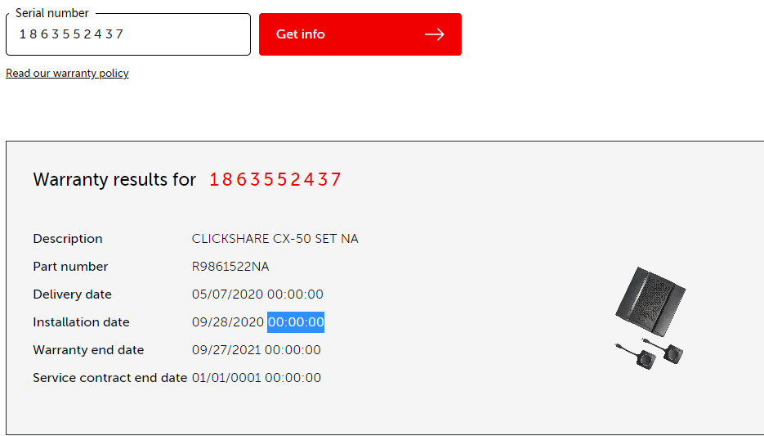

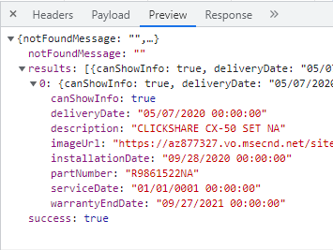

Bug ID:0002

[Issue and Background]

1.Brief description

Case10. The correct Warranty end date is “09/27/2021 09:16:22”, but get the wrong time “09/27/2021 00:00:00”

2.Platform/version info.

Browser is Chrome

3.Expected result

Should get correct info is “09/27/2021 09:16:22”

[Repeat Steps & Key Configuration]

1.Open the Chrome

2.Enter in the URL

3. Enter SN(1863552437) number

[Optional Information] - Logs, debug files, topo, scripts, screenshot

Same as Bug ID0001

Bug ID:0003

[Issue and Background]

1.Brief description

Case13. Enter spaces before SN( 1863552437) information is not displayed correctly

2.Platform/version info.

Browser is Chrome

3.Expected result

It is expected that the SN can still be correctly recognized when enter a space

[Repeat Steps & Key Configuration]

1.Open the Chrome

2.Enter in the URL

3. Enter SN( 1863552437) number

[Optional Information] - Logs, debug files, topo, scripts, screenshot

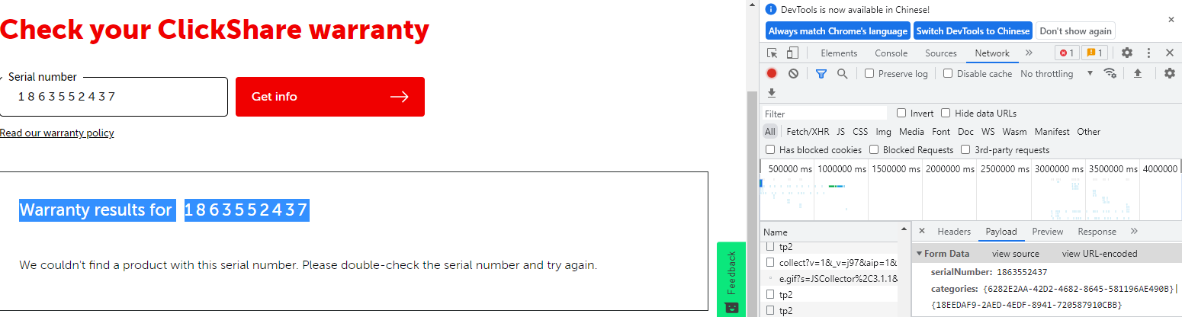

Bug ID:0004

[Issue and Background]

1.Brief description

Case10. The correct Warranty end date and Installation date is “09/27/2021 09:16:22” and “09/28/2020 09:16:22”, but get the wrong time “00:00:00”

2.Platform/version info.

Browser is Chrome

3.Expected result

Should get correct info is “09/27/2021 00:00:00”

[Repeat Steps & Key Configuration]

1.Open the Postman

2.Enter in the URL

3. Enter the body info such as

{

"serialNumber": "1863552437",

"categories" : "{6282E2AA-42D2-4682-8645-581196AE490B}|{18EEDAF9-2AED-4EDF-8941-720587910CBB}"

}

4.Click the Sent button to post the HTTP packet.

[Optional Information] - Logs, debug files, topo, scripts, screenshot

